EXONAUT FACT SHEET – UAE CAX

Exonaut is an integrated software suite that enables organizations to schedule, plan, carry out and evaluate (Design, Develop, Deliver Evaluate) exercises (CAX, Livex, CPX etc) efficiently facilitating a smooth transition into the AAR, training analysis and exploitation process. Exonaut simplifies this complex process as each user will only see the information relevant to them.

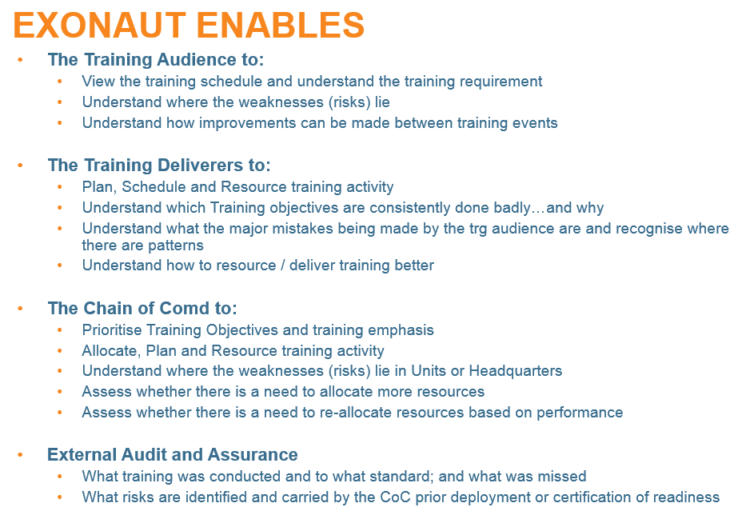

Exonaut can be used to support single exercises but is also a powerful training progression manager allowing the Chain of Command to identify, articulate training risk and better plan and resource subsequent activity.
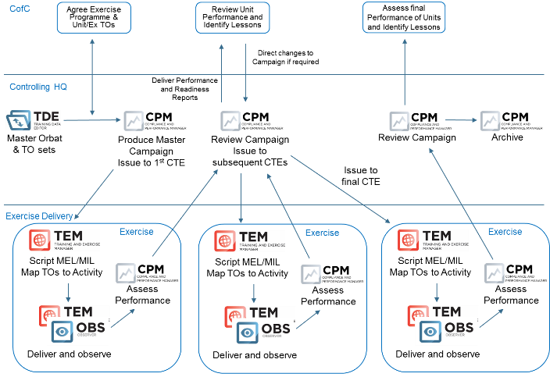

Designing and Developing Exercises. Exonaut allows exercise control staff to design, develop and deliver CAX to the highest international standards and using current NATO standards and terminology. Once created, organisations, training objectives, events, incidents and injects can be modified with ease and exploited on subsequent exercises.

Controlling the Exercise is simplified by user friendly displays that allow dynamic control of both resources and events. This can be conducted on a PC workstation or through a tablet with the built-in messaging system used to direct exercise controllers or observers. Controllers can either send messages one-to-one or to groups of users.
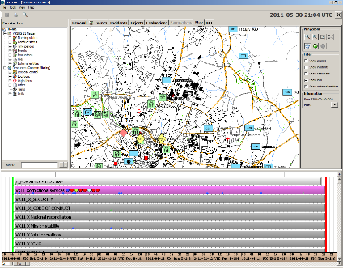

In addition, Exonaut can be integrated into the exercise C2 system in order that tasks can be assigned to the training audience through the standard means of communication in use on the exercise; in this way the Exonaut views remain confined to EXCON.

Observing the Exercise. Observations and assessments on exercise participant performance can be captured for use in AAR and subsequent analysis and exploitation in the Exonaut software either in the PC based system or on the mobile data tablets. Observer/Mentors can be equipped with the training objectives, dynamic views of the exercise progression, supporting doctrine and checks for trainers. User configurable reports and dashboards can be auto-populated from the observations and assessments produced.

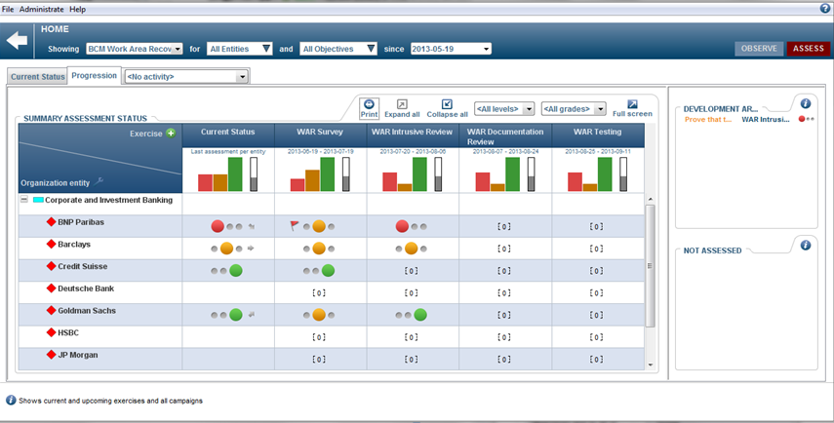

Permissions and security. Exercises often deal with sensitive information and in Exonaut access to all information is controlled by setting permissions at each level. Each user can be allocated a unique set of permissions so that sensitive information can be shared only with those entitled to see it - “chief observer” or “exercise director” for example.

Technical Characteristics. The system can be configured so that users can use three ways of connecting to the server depending on what level of security is required:

Local Area Network and USB sync of all tablets High Security (SECRET)
Local WiFi with standard encryption Medium Security (CLASSIFIED)
Internet using 3G/4G networks Low Security (RESTRICTED)

Exonaut works on a SQL database with a standard webserver powering all the user clients making it easy to use as no installations are required on the workstations. For mobile devices Exonaut supports the “Bring your own device” concept with mobile APPs supported on iOS, Android and Windows.

For all options it can be arranged for additional encryption to allow for higher security levels.

